Using clSecurity

This class has been created to try and take some of the headache out of creating your own security code. The design allows for multiple users with functionality for a web front-end and a windows desktop back-office. There is the option for assigning administrators within the system but there are some limitations on this implementation! Firstly users are either administrators or simple users; there are no multiple levels of authorisation. The design will need extending to allow for this. Management of accounts is limited in some cases this will require direct editing of the data in the table. There is no differentiation between staff and customers. A person who signs up via the web interface automatically has an account on the back office application.

Overview of Features
Perhaps the best place to start is to take a look at the final implementation and see what the class has to offer. You will need to download and extract Address Book Secure.
Once started in Visual Studio take a look at the configuration...
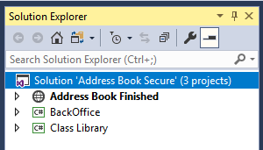
Within the solution there are three projects.
- Address Book Finished which is the web based front end
- BackOffice the staff facing backend admin system running as a windows desktop application
- Class Library containing all of the middle layer code
Out of the box the front end should be the start up project – run the program to see the main screen.
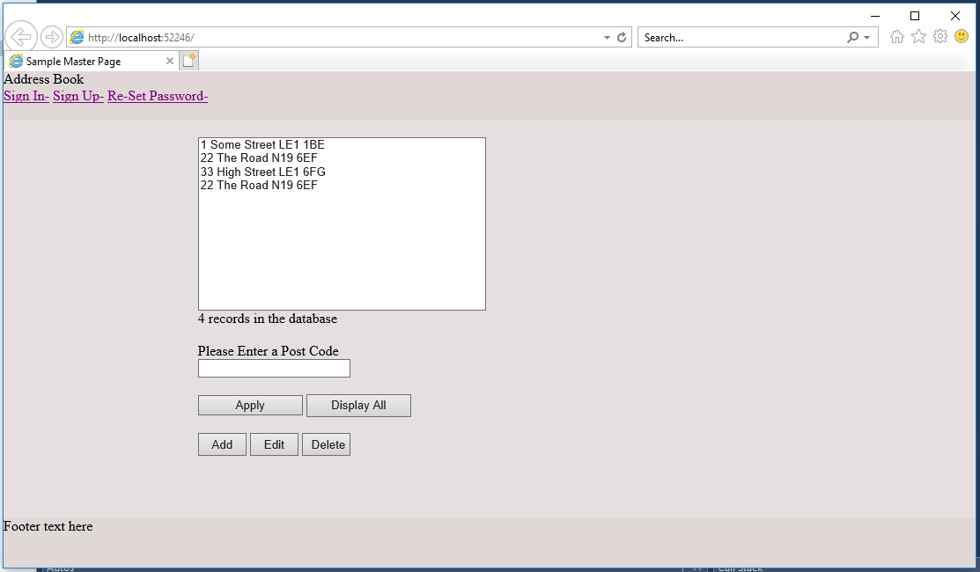
There are probably more features in the implementation than we shall cover here but first things to note are the following...
- The web application incorporates a master page and external CSS to provide consistent layout across all pages
- There is at this point no authorisation as such every user sees the same data regardless of who they are
- The system does change based on authentication. Note that the links at the top left will change as soon as somebody has logged in
- The interface isn’t terribly pretty and needs a good tidy up!
To use the system you will need to create an account, so click on the link for “Sign-up”. This should take you to the following screen...
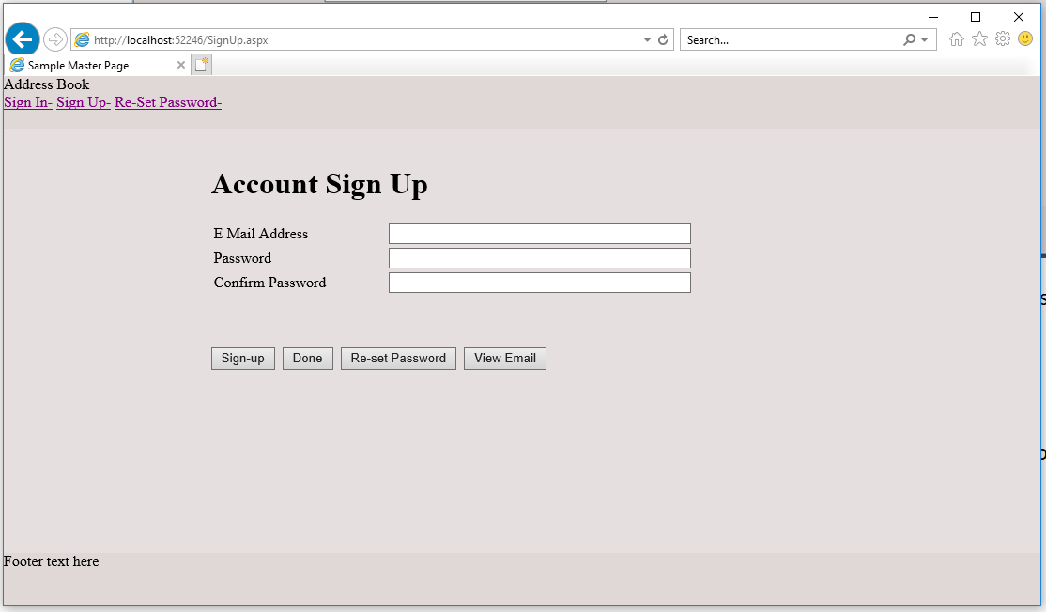

Before doing anything, press sign-up whilst leaving the field blank!
Note that the class already incorporates a good set of validation messages for you to use in your own application.
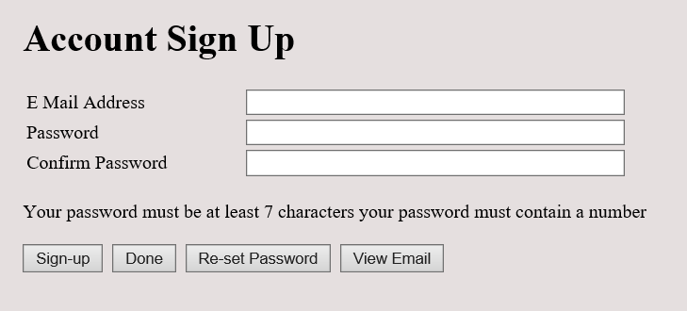
To sign up for an account you will need to enter your email address and type your password twice like so...
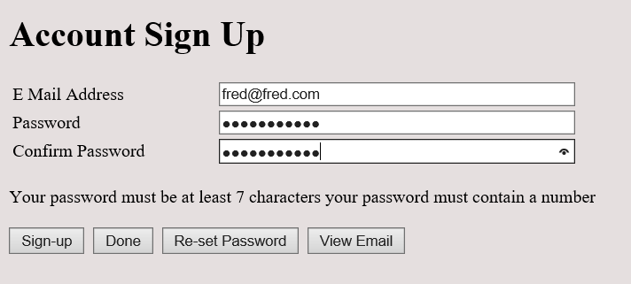
Press Sign-up again and the account should be created for you.
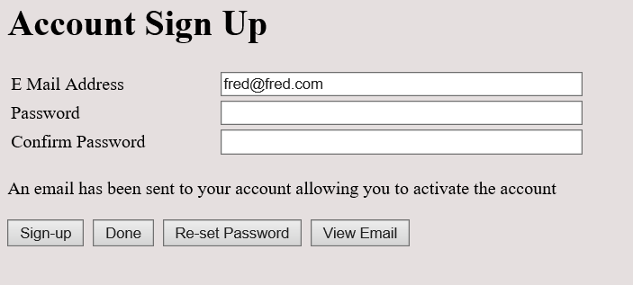
One issue with web based sign up is that we don’t want people to sign up to our site with fake email addresses. The system is able to send verification emails to the user in order to activate the account. If this process is not followed then the user will not be able to sign in.
There is a problem though. Without setting this up on a real server it can be a bit of a problem closing the loop between sign-in, email confirmation and final verification, to fix this we have added the “View Email” button.
Press View-Email and you will be taken to a page which displays the email that would have been sent to your account...
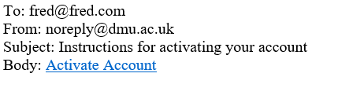
In order to complete the activation process, click the Activate Account link...
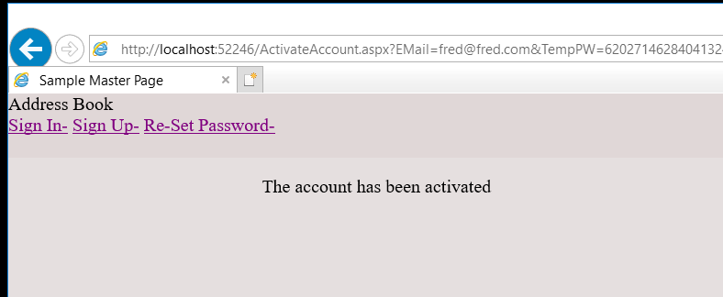
Now you should be able to sign-in without any problem...
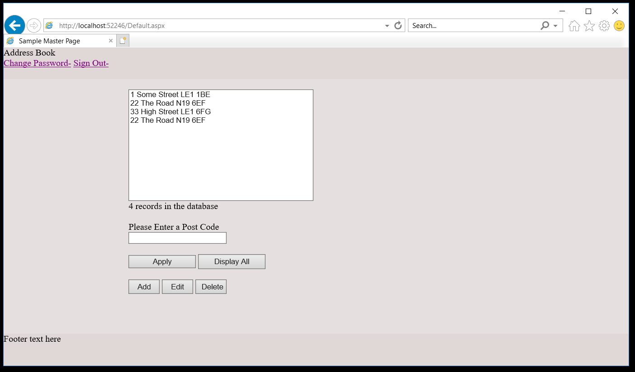
The system now recognises the user as authenticated and modifies the range of options available on the top left of the screen.
We are now able to...
- Change Password
- Sign Out
Change password takes you to the following screen which should hold no surprises...
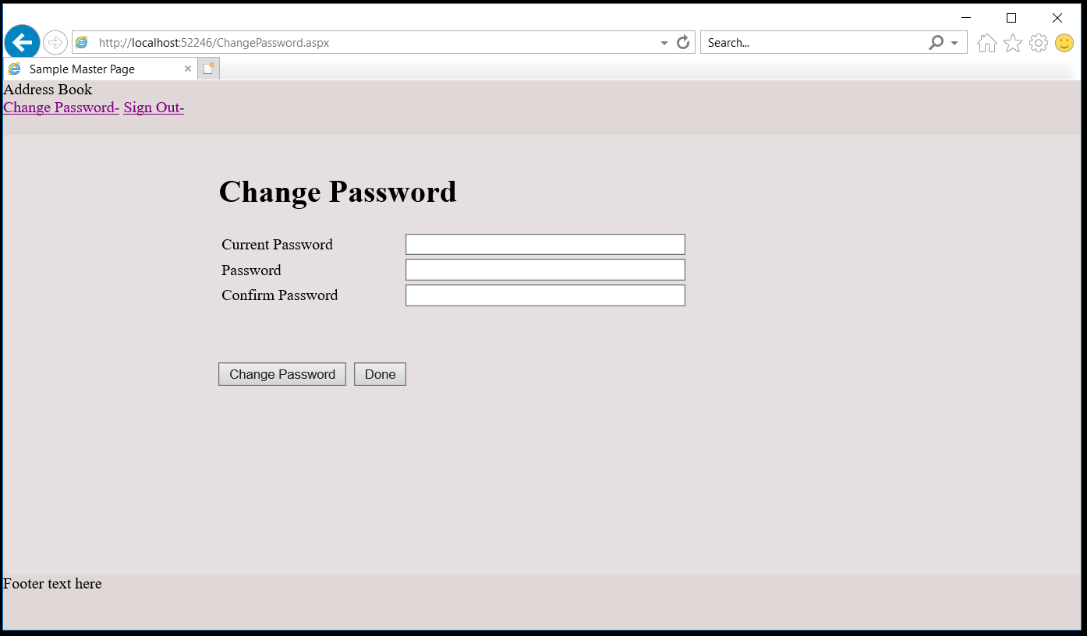
Sign-out will take you back to the first unauthenticated main page...
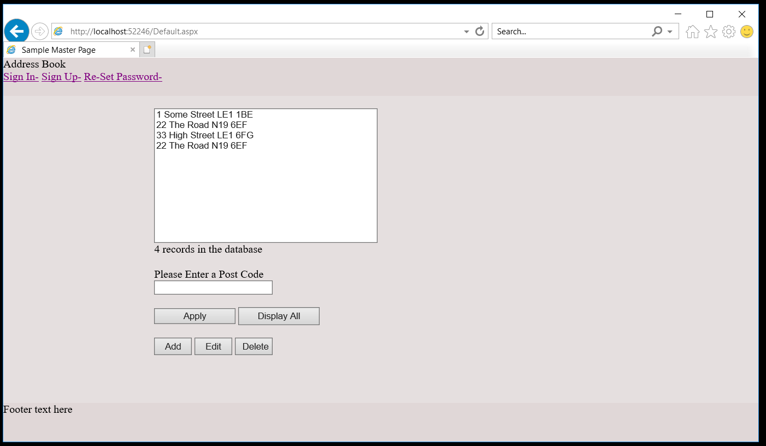
Lastly there is the option to allow a user to re-set their password like so...
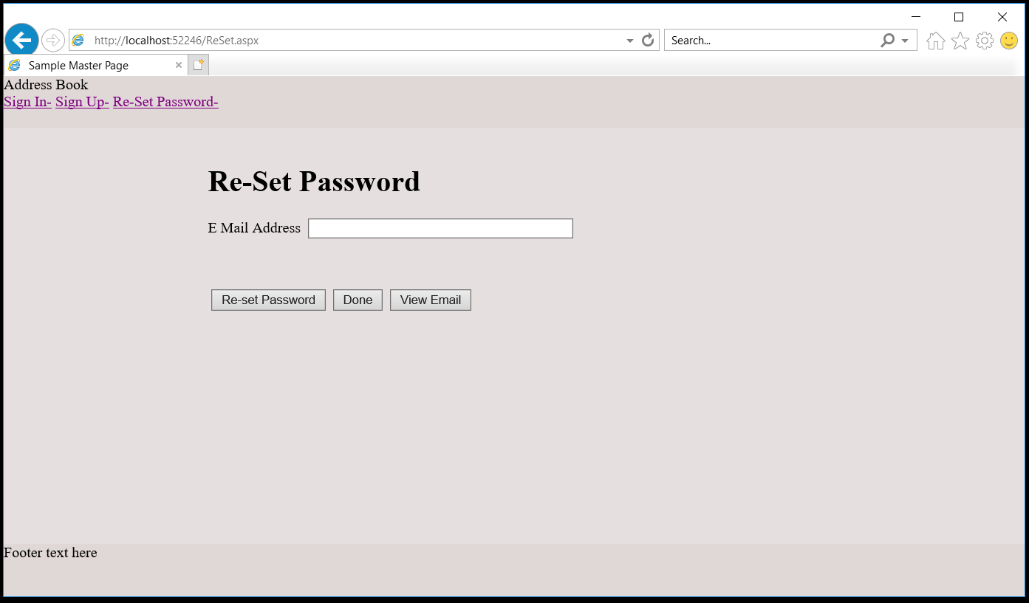
Typing in the email address and pressing re-set will trigger an email containing instruction on how to re-set the password.
So enter an email address and re-set the password...
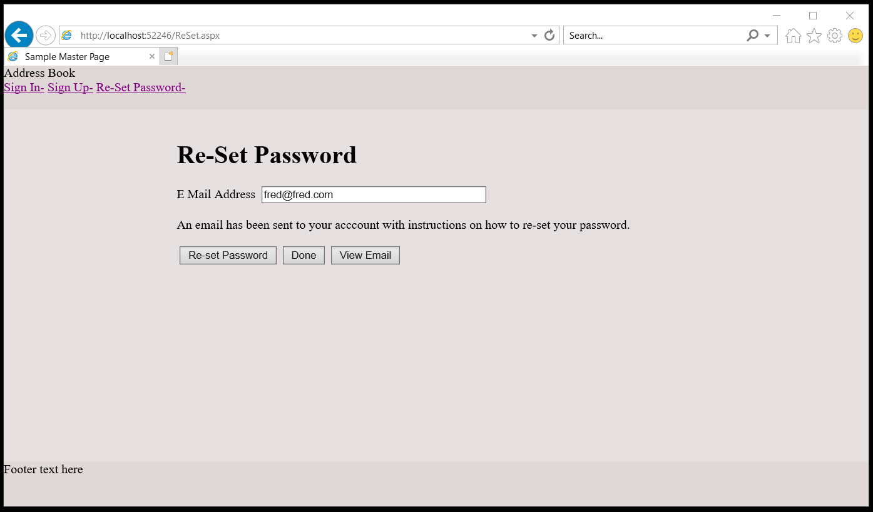
As above we need to take into account the limitations on emails, so to view the message click on View Email...
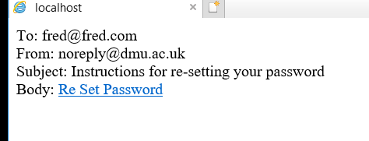
Follow the link to complete the process...
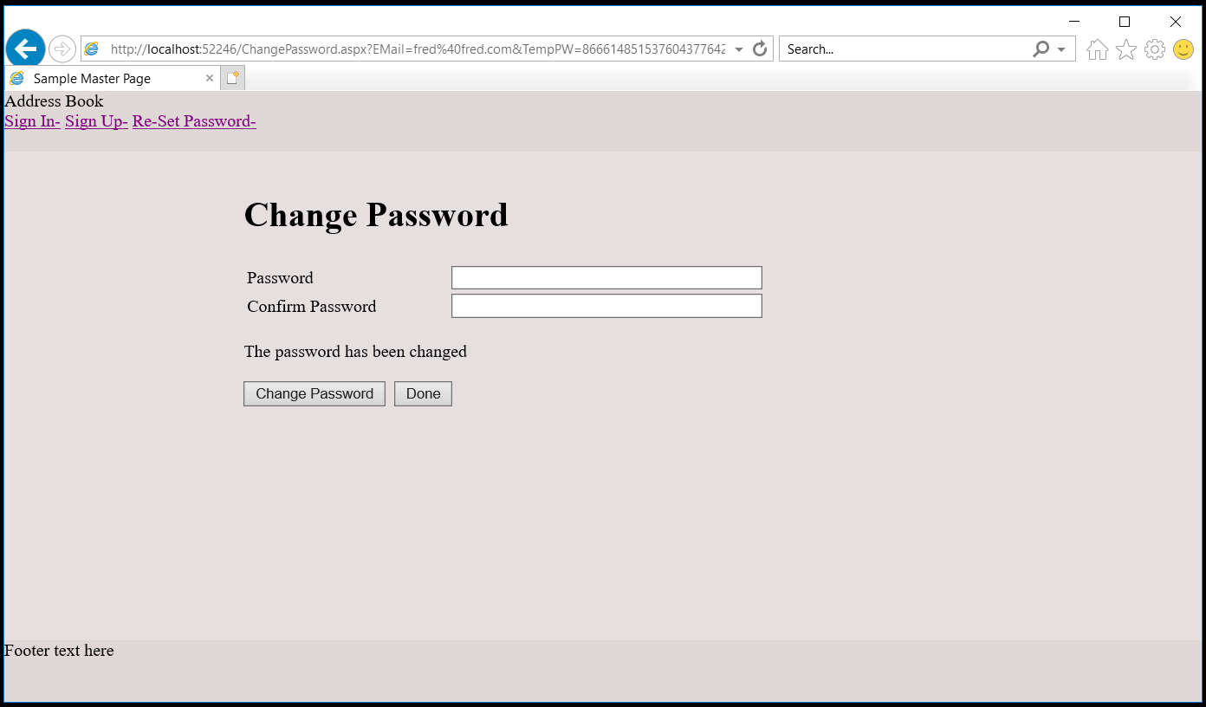
That concludes the overview of the customer facing front end, now we will have a play with the back office.
Right click on the back office and make it the start-up project...
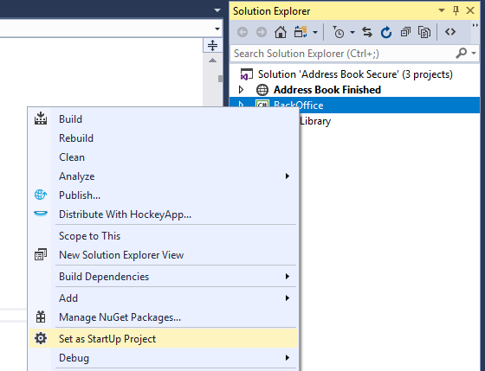

Now run the solution to see what it does...
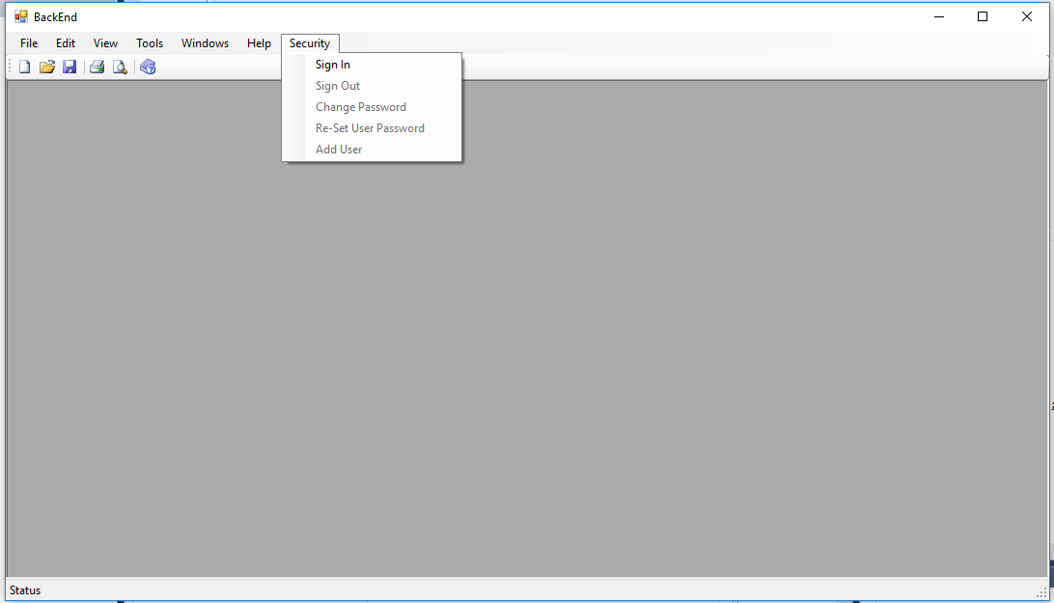
It is worth pointing out at this stage that the business rules / use cases for a back office system are slightly different for a web based front end.
The main difference, is that back office systems don’t allow users to sign themselves up to the system; this is handled by the administrator. This being the case it also isn’t necessary to include some sort of email verification. In a similar vein if a person forgets their password it is usually down to the admin to fix this rather than allowing the user to do so via an email.
Given that we need to include admin and non admin users on the back end we need to include not just authentication but also some measure of authorisation to control access to admin functions.
From the security menu sign-in as our existing user like so...
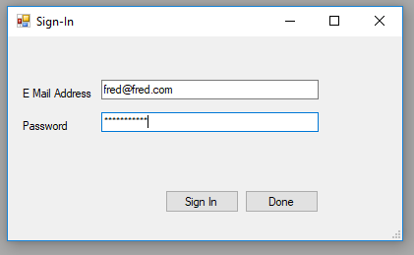
Since this presentation layer uses the same class library as the web interface, they both share the same database. This means that any users added via the front office will also be able to log in via the back office...
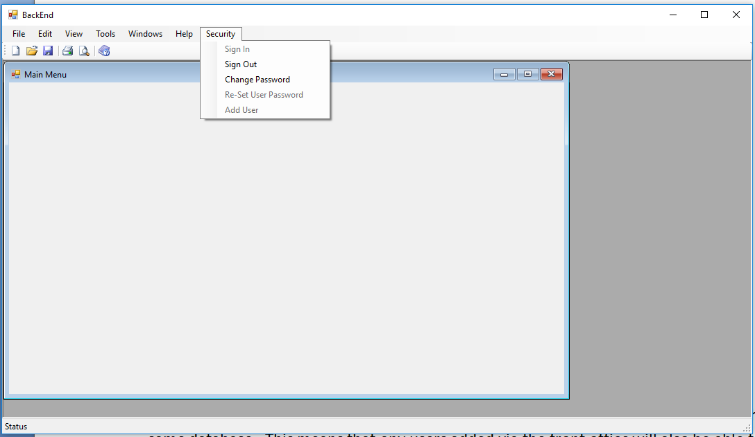
You should see the dummy Main Menu pop up but also note that now different options have been activated on the security menu, namely “sign-out” and “change password. Play with these options to see that they work as you expect.
More importantly note that “re-set user password” and “add user” are not enabled as these are both admin functions. To enable these we will need to create an admin user and unfortunately the only way at the moment to do that is to modify the database directly.
Stop the program and open the table tblAccount to view the data...
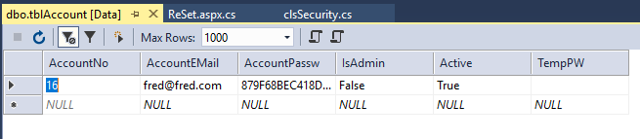
To turn our existing user into an admin change IsAdmin from false to true.
While we are here it may be worth taking a first look at some of the other features of the table.
- AccountEMail is currently used as the user name of the account
- AccountPassword is a salted hash
- IsAdmin needs to be changed manually (until I get round to changeing things!)
- Active is used as part of the email activation process and may also be used for disabling an account
- TempPW is used on the web front end as part of re-setting a forgotten password
So, assuming you have modified the user to make them admin, like so...
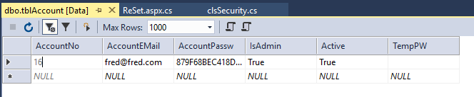
Run the program again, sign in and then see what the menu options look like...
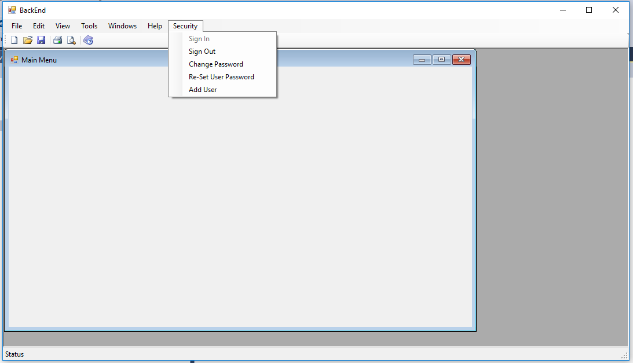
This time due to being admin all of the menu options should be available.
Let’s add a new user as admin, so select “Add-User”...
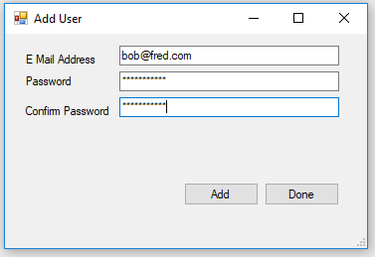
It is often the case with back end systems that the admin will add them with the new person physically present, perhaps as a new member of staff. If this is the case then the new user with the administrator’s supervision would add the new account themselves. There are potentially other sets of business rules but this is one possible example.
Note that once the account is created there is the option to continue adding staff until the process is completed.
Sign out as admin and now sign in as the new user. Since they are not admin they should only see a limited set of menu options...
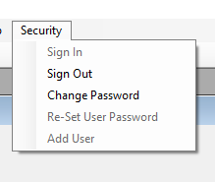
So what happens if they forget their password? In this case rather than re-setting it themselves they need to ask the admin to do it for them.
Sign back in as the admin and access “re-set user password”...
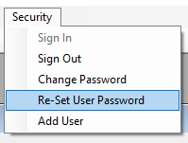
This displays the following screen...
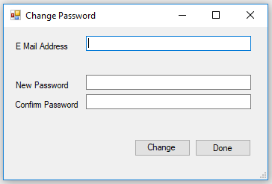
Since I am the admin I am able to re-set the password for any user on the system.
Compare this with the screen when I want to change my own password...
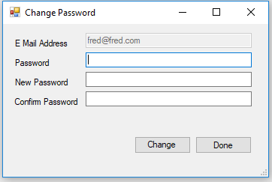
Note that I can only change the password for my own account whereas an admin can do this for all accounts.
We have now looked at the functionality available for both customer facing front end and staff facing back end.

clsSecurity Internal Design

As a class diagram we have the following to consider...
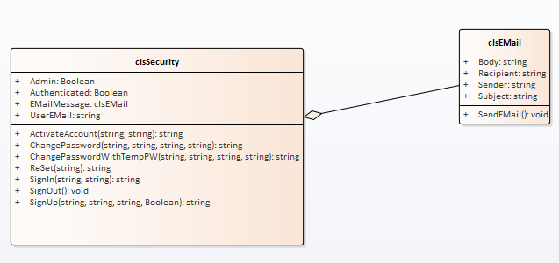

clsEmail
Given that I have only given you the code for clsSecurity it is a fair question to ask what about the email class?
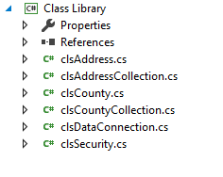
No clsEMail!
This is a little naughty but clsEMail is actually embedded in clsSecurity. Take a look at the code for clsSecurity and you will see the class definition at the top...
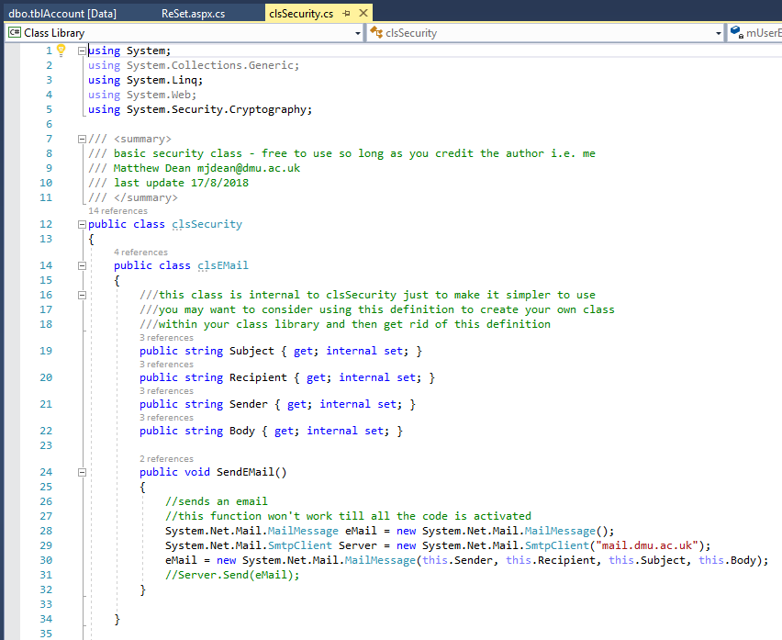
This embedded class comes free of charge and is designed like this to make including the features simpler. If you want at some point to take the class definition out of here and give it its own file, please feel free to do so.
clsEMail is used to represent an email, provide basic send functionality and is also used on the view email feature we looked at in the first examples above.

clsSecurity

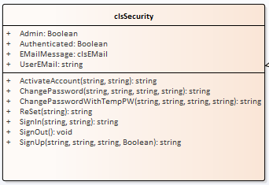
This class is the one that handles all of the security features we have seen so far.
There are the following attributes to make use of...
- Admin indicates true if the authenticated user is an administrator
- Authenticated is used to see if the current user is in fact signed in
- EMailMessage exposes the last sent email message
- UserEMail allows access to the email address of the current user which is also their user ID in this design
There are also the following operations along with a brief description...
Activate Account: Used as part of the email activation process, accepts the user email and a temporary password as parameters
ChangePassword: Accepts the email address and current password for authentication along with two copies of the new password to reduce the risk of typos
ChangePasswordWithTempPW: accepts the email address and a system generated temporary password along with two copies of the new password. This function is used when a user needs to re-set their password on the web
ReSet: Sends out an email containing a temporary password to the email address specified as a parameter
SignIn: accepts the email address and password of the user to be authenticated setting the classes authenticated attribute to true if successful
SignOut: Sets the class to an non-authenticated state
SignUp: Used to create a new user on the system. Parameters required are email address, duplicate password and a Boolean active parameter. The active parameter determines of an activation email is sent to the new user. In the case of web based sign up active should be set to false to force a verification email. In the case of a back office sign up this may be set to true to bypass this step of the process.
Below is a screen shot of all attributes / parameters along with their data types...
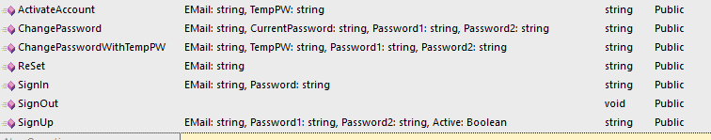

Implementing clsSecurity
Rather than using the Address Book as your starting point for adding security to your system I have also provided a more stripped down version of the system called Security. Unzip the file and look at the contents in Visual Studio...
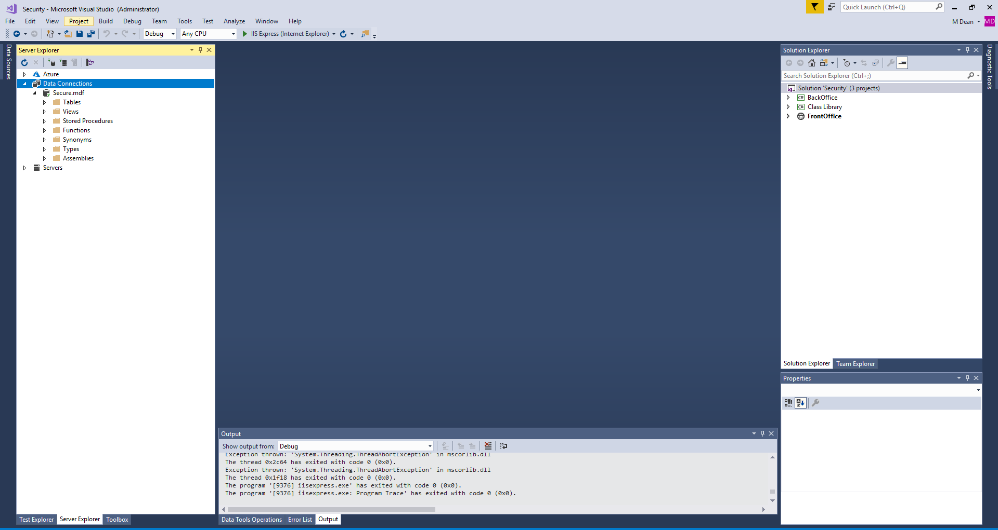
In this solution you have the three projects, BackOffice, FrontOffice and Class Library. This time I have not included the extra features of the address book.

Adding the Code to a Simple Web Site
For this example we shall add the code to a simple single project web site.
Create a new web site called security demo like so...
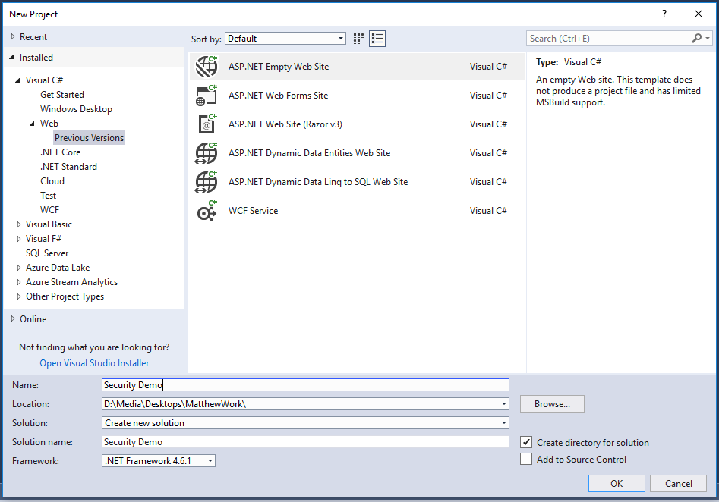
Within the web site create the new Default.asp page like so...
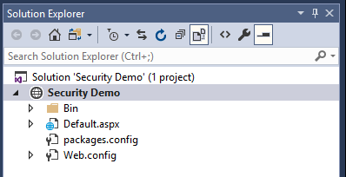
Next create the App_Data and App_Code folders...
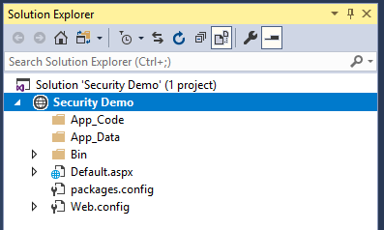
The next step is to copy the required files into our web site using file explorer.
With the contents of the zip file on screen with the folders for your new web site copy the following files from the front office to your new web site...
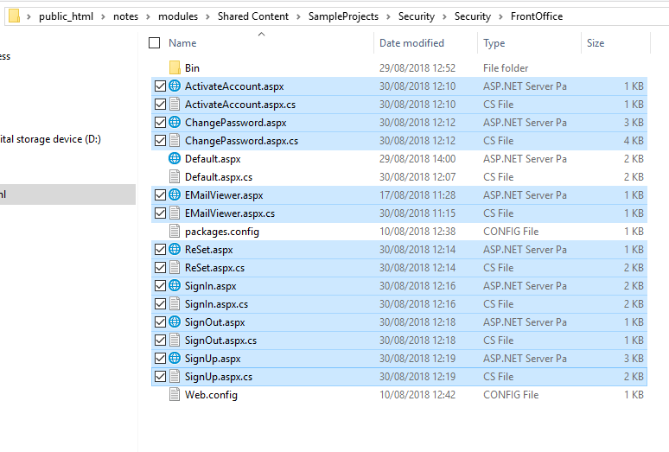
(Don’t copy the page Default.aspx or it will overwrite the one you have just created)
Next copy the classes clsSecurity and clsDataConnection (if you don’t already have it) from the Class Library folder to your App_Code folder...
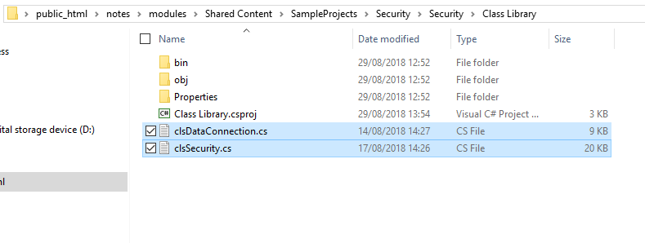
Lastly copy the database file to your App_Data folder...
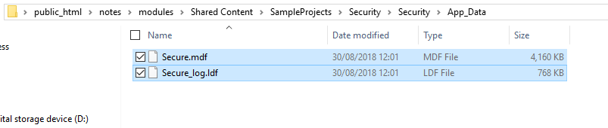
If this has been done correctly then you will see the following in Visual Studio once you refresh the web site contents...
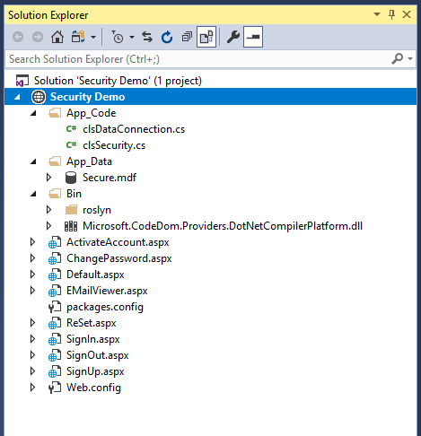
Now run the web site to make sure there are no errors.

Adding the Code to Default.aspx
The code for implementing basic security is mostly handled by the class.
The presentation layer code is pretty simple.
Create a basic series of buttons on your ASPX page using the following code...
<%@ Page Language="C#" AutoEventWireup="true" CodeFile="Default.aspx.cs" Inherits="_Default" %>

<!DOCTYPE html>

<html xmlns="http://www.w3.org/1999/xhtml">
<head runat="server">
<title></title>
</head>
<body>
<form id="form1" runat="server">
<div>
<asp:Button ID="btnSignIn" runat="server" OnClick="btnSignIn_Click" Text="Sign In" width="160px" />
<br />
<br />
<asp:Button ID="btnSignUp" runat="server" OnClick="btnSignUp_Click" Text="Sign Up" width="160px" />
<br />
<br />
<asp:Button ID="btnReSet" runat="server" OnClick="btnReSet_Click" Text="Re Set Password" width="160px" />
<br />
<br />
<asp:Button ID="btnChangePassword" runat="server" OnClick="btnChangePassword_Click" Text="Change Password" Width="160px" />
<br />
<br />
<asp:Button ID="btnSignOut" runat="server" OnClick="btnSignOut_Click" Text="Sign Out" width="160px" />
</div>
</form>
</body>
</html>

This will create the following layout...
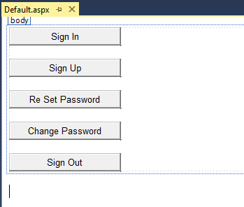
All you need to do next is to add the appropriate code.
using System;
using System.Collections.Generic;
using System.Linq;
using System.Web;
using System.Web.UI;
using System.Web.UI.WebControls;

public partial class _Default : System.Web.UI.Page
{
//create an object based on the security class
clsSecurity Sec;

protected void Page_Load(object sender, EventArgs e)
{
//get the security data from the session
Sec = (clsSecurity)Session["Sec"];
//if it is null then this is the first run of the site
if (Sec == null)
{
//initialise the object
Sec = new clsSecurity();
//save it to the session
Session["Sec"] = Sec;
}
//set the state of the menu buttons
Authenticated(Sec.Authenticated);
}

protected void btnSignIn_Click(object sender, EventArgs e)
{
//go to sign in
Response.Redirect("SignIn.aspx");
}

protected void btnSignUp_Click(object sender, EventArgs e)
{
//go to sign up
Response.Redirect("SignUp.aspx");
}

protected void btnReSet_Click(object sender, EventArgs e)
{
//go to re-set
Response.Redirect("ReSet.aspx");
}

protected void btnChangePassword_Click(object sender, EventArgs e)
{
//go to change password
Response.Redirect("ChangePassword.aspx");
}

protected void btnSignOut_Click(object sender, EventArgs e)
{
//go to sign out
Response.Redirect("SignOut.aspx");
}

void Authenticated(Boolean Auth)
{
//sets the visibility of the buttons on the main menu based on authentication state
//if not logged in then dsiplay the following
btnSignIn.Visible = !Auth;
btnSignUp.Visible = !Auth;
btnReSet.Visible = !Auth;
//if logged in display the following
btnChangePassword.Visible = Auth;
btnSignOut.Visible = Auth;
}
}
There are a few things to note above.
To use a given feature in a button all you need to do is redirect to the appropriate web form. For example to access the sign in page we do the following...
protected void btnSignIn_Click(object sender, EventArgs e)
{
//go to sign in
Response.Redirect("SignIn.aspx");
}

Note at the top of the code what is going on with the object called Sec...
public partial class _Default : System.Web.UI.Page
{
//create an object based on the security class
clsSecurity Sec;

First we create a non instantiated object with page level scope.
The next step is to check this object in the pages load event to see if it is set up correctly, i.e. not null...
protected void Page_Load(object sender, EventArgs e)
{
//get the security data from the session
Sec = (clsSecurity)Session["Sec"];
//if it is null then this is the first run of the site
if (Sec == null)
{
//initialise the object
Sec = new clsSecurity();
//save it to the session
Session["Sec"] = Sec;
}
//set the state of the menu buttons
Authenticated(Sec.Authenticated);
}

If the object is null then a copy is instantiated and saved to the session object called “Sec” this makes the data available to other web pages.
Finally the load event calls the function Authenticated passing as a parameter the Authenticated state of the object i.e. has the user logged in or not.
The Authenticated function turns buttons on the page on or off depending on if the user is logged in or not...
void Authenticated(Boolean Auth)
{
//sets the visibility of the buttons on the main menu based on authentication state
//if not logged in then dsiplay the following
btnSignIn.Visible = !Auth;
btnSignUp.Visible = !Auth;
btnReSet.Visible = !Auth;
//if logged in display the following
btnChangePassword.Visible = Auth;
btnSignOut.Visible = Auth;
}

This function uses a bit of Boolean logic to make it a bit cleaner.
For example the following line...
btnSignIn.Visible = !Auth;

Is the same as the following code...
If (Auth == false)
{
btnSignIn.Visible = true;
}

Using your own Database
One problem you will face as the design currently stands is when you want to have your own database as well as the security database. As things stand the class clsDataConnection will get upset if you have two databases in your App_Data folder.
The simplest way to get round this is to create the tables and stored procedures from the security database in your own data file.
To make life slightly simpler I have provided the code to allow you to generate them yourselves (Don’t copy and paste the hashes!)...
########################
CREATE TABLE [dbo].[tblAccount] (
[AccountNo] INT IDENTITY (1, 1) NOT NULL,
[AccountEMail] VARCHAR (50) NULL,
[AccountPassword] VARCHAR (50) NULL,
[IsAdmin] BIT NULL,
[Active] BIT NULL,
[TempPW] VARCHAR (50) NULL,
PRIMARY KEY CLUSTERED ([AccountNo] ASC)
);
########################
CREATE PROCEDURE sproc_tblAccount_UpdateTempPW
@AccountEMail varchar(50),
@TempPW varchar(50)

AS
update tblAccount
set TempPW=@TempPW

where AccountEMail=@AccountEMail;

RETURN 0
########################
CREATE PROCEDURE sproc_tblAccount_UpdatePassword
@AccountEMail varchar(50),
@AccountPassword varchar(50)

AS
update tblAccount
set AccountPassword=@AccountPassword,
TempPW=''

where AccountEMail=@AccountEMail;

RETURN 0
########################
CREATE PROCEDURE sproc_tblAccount_FilterByEmailAndTempPW
@AccountEMail varchar(50),
@TempPw varchar(50)
AS
SELECT * from tblAccount where AccountEMail=@AccountEMail and TempPw=@TempPw;
RETURN 0
########################
CREATE PROCEDURE sproc_tblAccount_FilterByEmailAndPassword
@AccountEMail varchar(50),
@AccountPassword varchar(50)
AS
SELECT * from tblAccount where AccountEMail=@AccountEMail and AccountPassword=@AccountPassword and Active=1;
RETURN 0
########################
CREATE PROCEDURE sproc_tblAccount_FilterByEmail
@AccountEMail varchar(50)

AS
SELECT * from tblAccount where AccountEMail=@AccountEMail;
RETURN 0
########################
CREATE PROCEDURE sproc_tblAccount_Add
@AccountEMail varchar(50),
@AccountPassword varchar(50),
@Active bit
AS
insert into tblAccount (AccountEMail, AccountPassword, IsAdmin, Active)
values (@AccountEMail, @AccountPassword,0, @Active);

RETURN @@Identity
########################
CREATE PROCEDURE sproc_tblAccount_Activate
@AccountEMail varchar(50)

AS
update tblAccount
set Active=1,
TempPW=''

where AccountEMail=@AccountEMail;

RETURN 0
########################
Once you have created the above don’t forget to make sure you only have your database in the App_Data folder and not the extra security one.

